**Facial Recognition using PIL and face_recognition module in Python**

Project report submitted in partial fulfillment of the requirements for the

Award of the Degree of B.Tech in

Computer Science and Engineering.

**By Mentor:-**

**Anant Bhandari, Mr. Akshay Rajput**

**Semester 4**

**B.Tech (CSE)**

**Univ. Roll No: 2016628**

**Department of Computer Science and Engineering**

**Graphic Era Deemed to be University**

**Dehradun-248002**

**Problem Statement : Real-Time face recognition system using PIL(Python Image Library) in python.**

An application is required that will recognize faces by using Real-Time Face Recognition System. The faces can be detected and recognized with high accuracy by training the machine using a dataset containing various pixel configurations of various images of the same person.

**Motivation :** Facial recognition is a big leap in the tech world as it has allowed human-machine interaction to step up at altogether a whole new level. Now your machine can identify you and based upon your identification it can open up your personalized window.

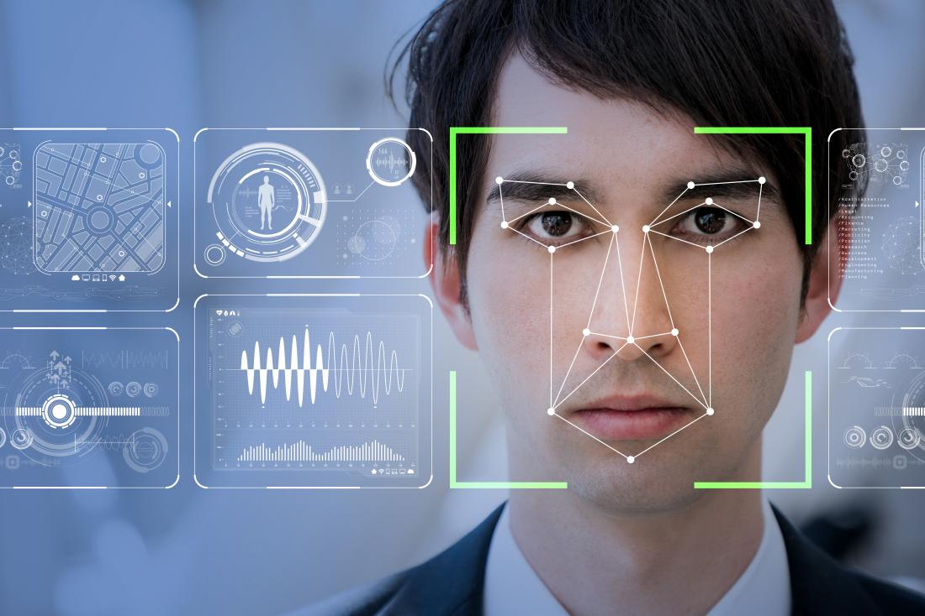

**Tools Used**

This facial emotion detection system has been developed using following tools and frameworks :

1. Python face_recognition module
2. Python Imaging Library

**Python face_recognition Module**

Python is an interpreted high-level general-purpose programming language. Its design philosophy emphasizes code readability with its use of significant indentation. Its language constructs as well as its object-oriented approach aim to help programmers write clear, logical code for small and large-scale projects.

**Face Recognition**

Recognize and manipulate faces from Python or from the command line withthe world’s simplest face recognition library.

Built using  ’s state-of-the-art face recognition

built with deep learning. The model has an accuracy of 99.38% on the

Labeled Faces in the Wild benchmark.

This also provides a simple face_recognition command line tool that lets

you do face recognition on a folder of images from the command line!

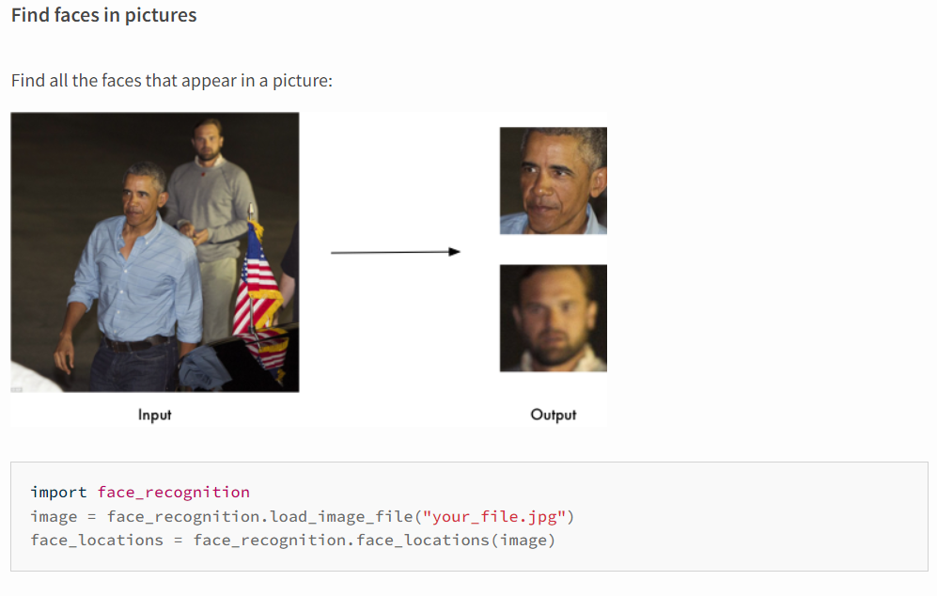

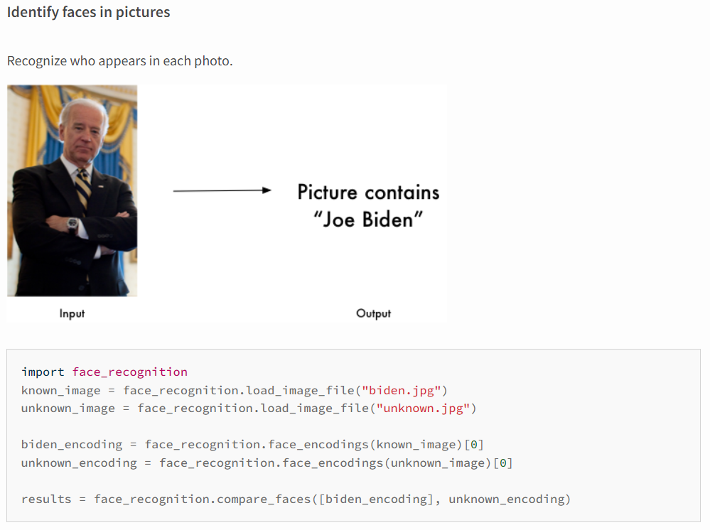

**Methodology**

For developing this system Python is used , in which  PIL library and face_recognition Module have been primarily used as the tools to detect face and recognize it in real-time.

Steps involved in building this model:

1.Preparing Dataset

2.Training network

3.Testing Network

**Applications**

There can be a plethora of implementations of face recognition system, a few of them are mentioned below:

* Attendance System
* Automobile Security.
* Access Controls(Seen in mobile phones)
* Health Care (in diagnosing diseases), etc.

But, the application that I would like to implement in my future endeavors with facial recognition technology is “**Merging the emotion based music recommender system with facial recognition**”.

* Just to brief about the concept: By merging these two technologies, **I intend to build an App** that will **read your face and analyze the emotions and play your favorite song** from a pre-maintained playlist or will choose a random song based upon the mood if the user hasn’t inputted the playlist in the App.

**Output**

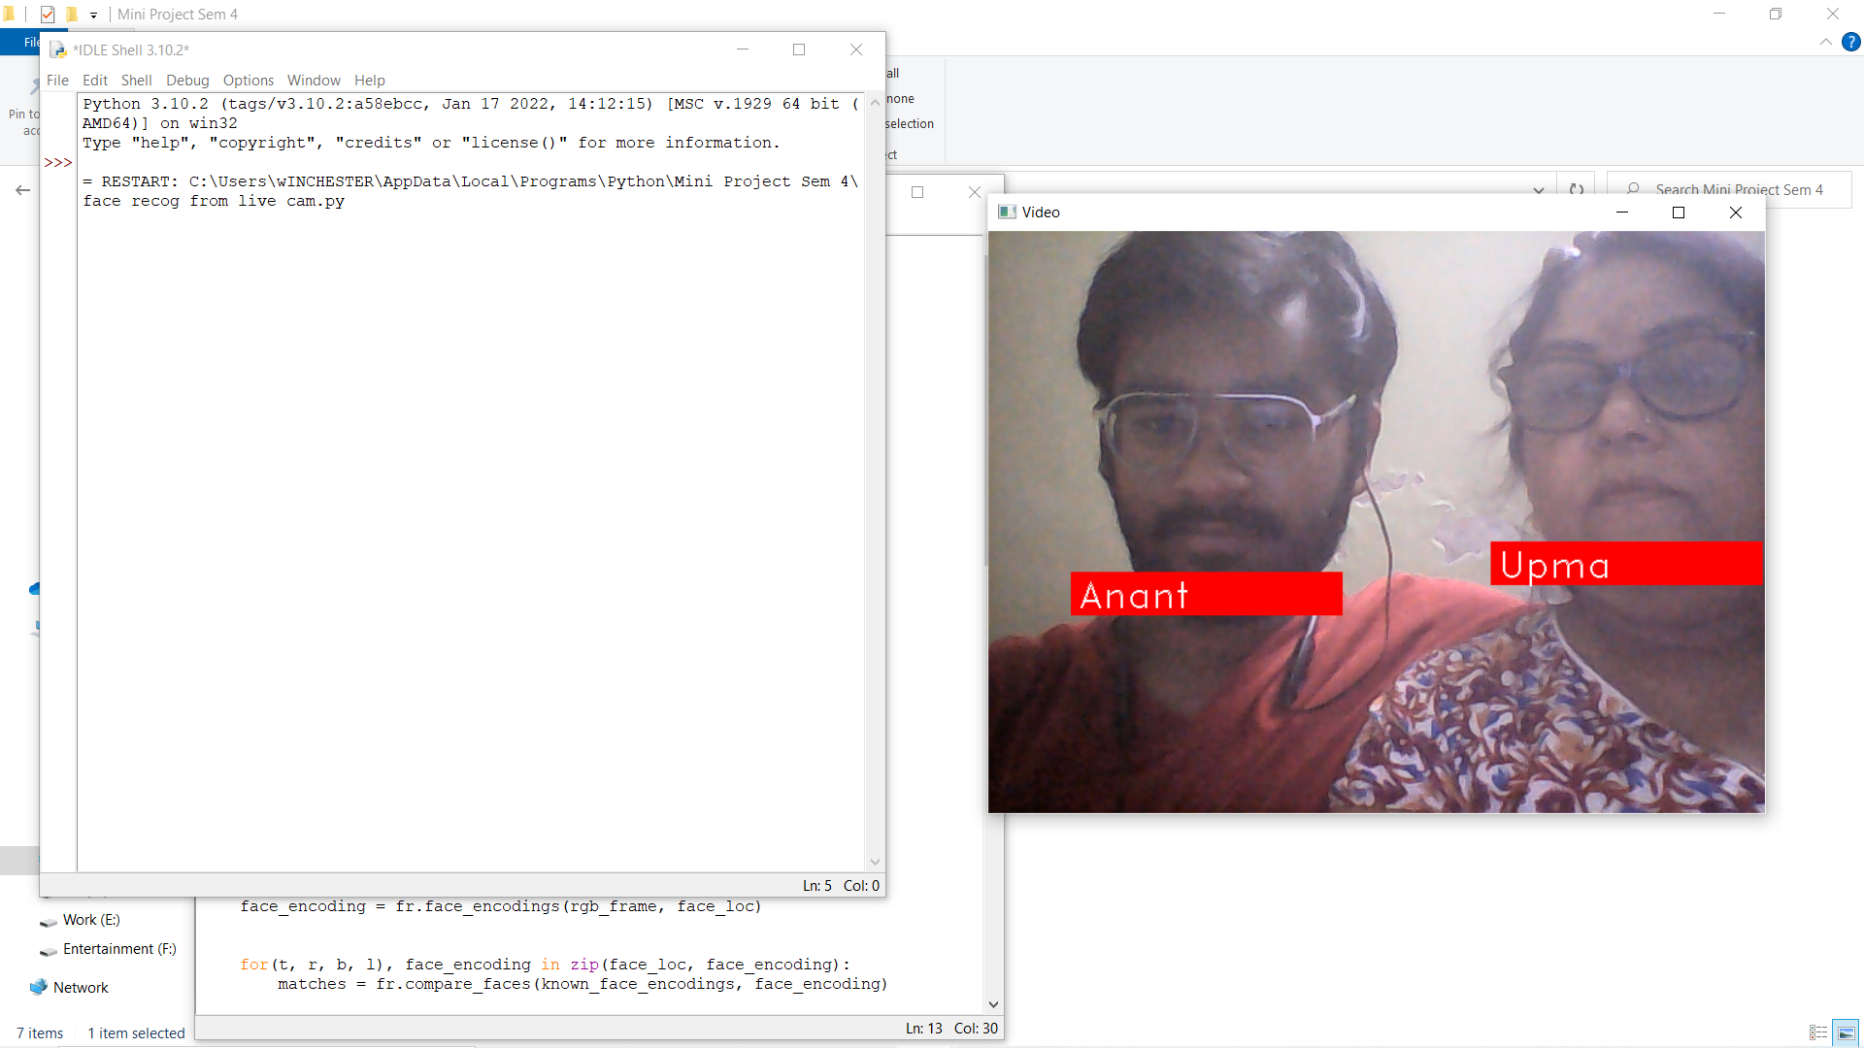

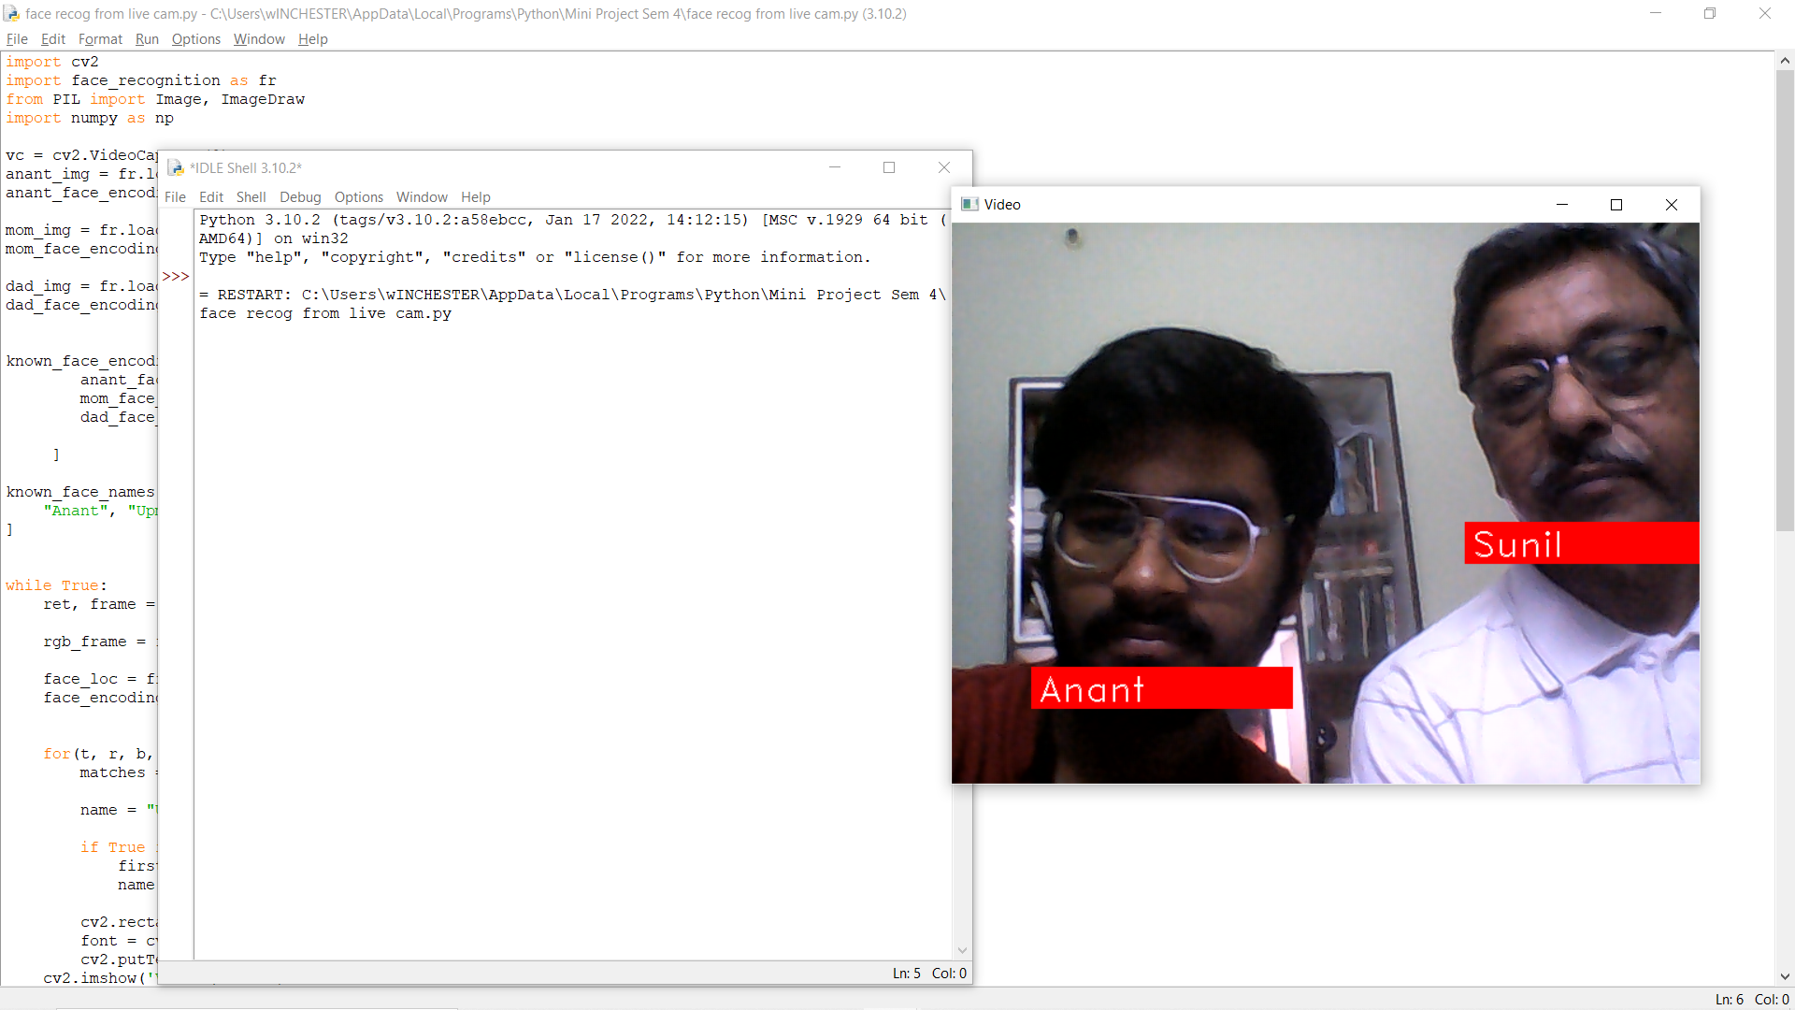

**-Thank you**

**____________________________________________________________________________________**